Department head:

Assign Temporary Department Head

Click “Assign Temporary Department Head” link from menu.

Select temporary department head and click “Remove”

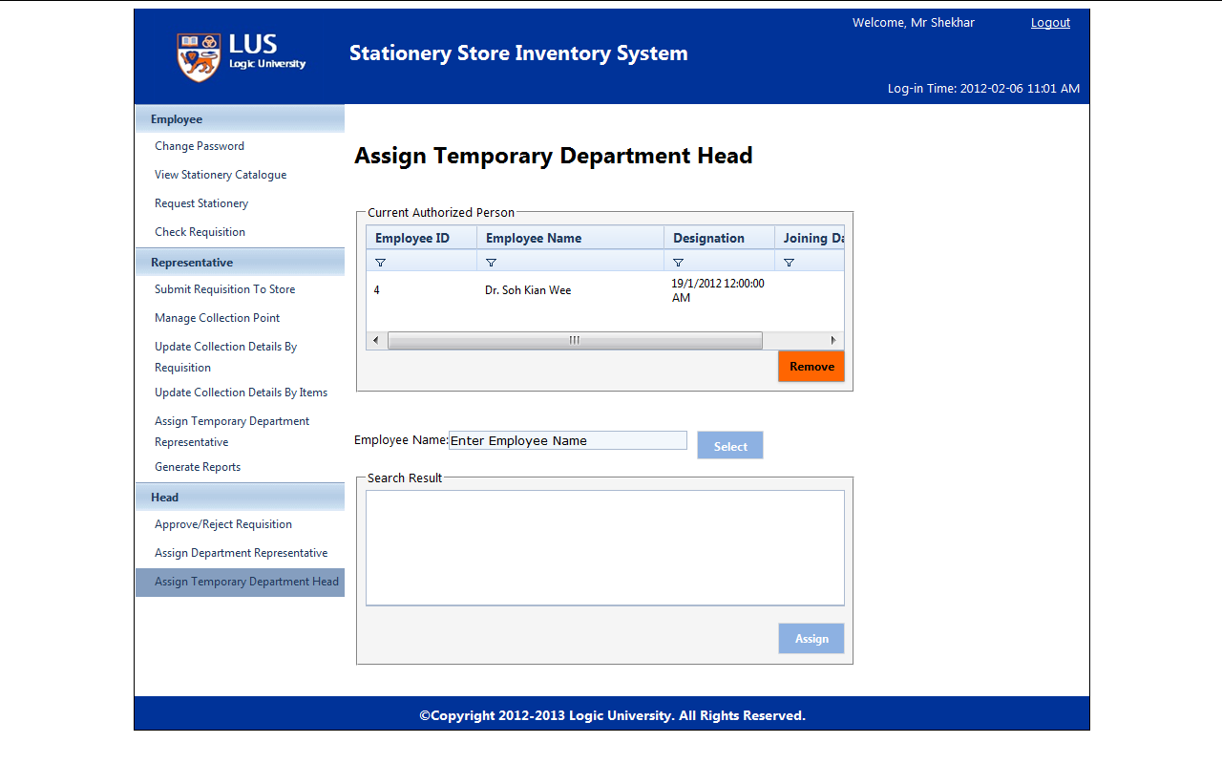

Search employee name and click “Select”

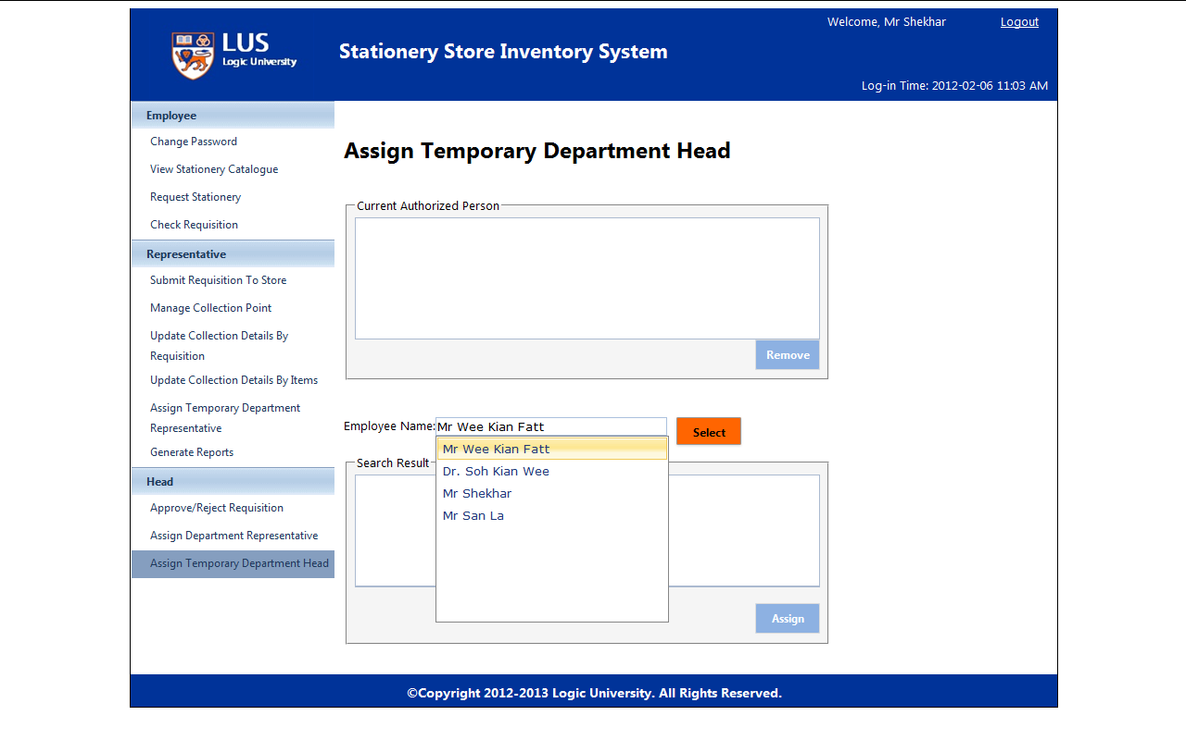

Click ”Assign” and see the assigned employee in temporary department head list

